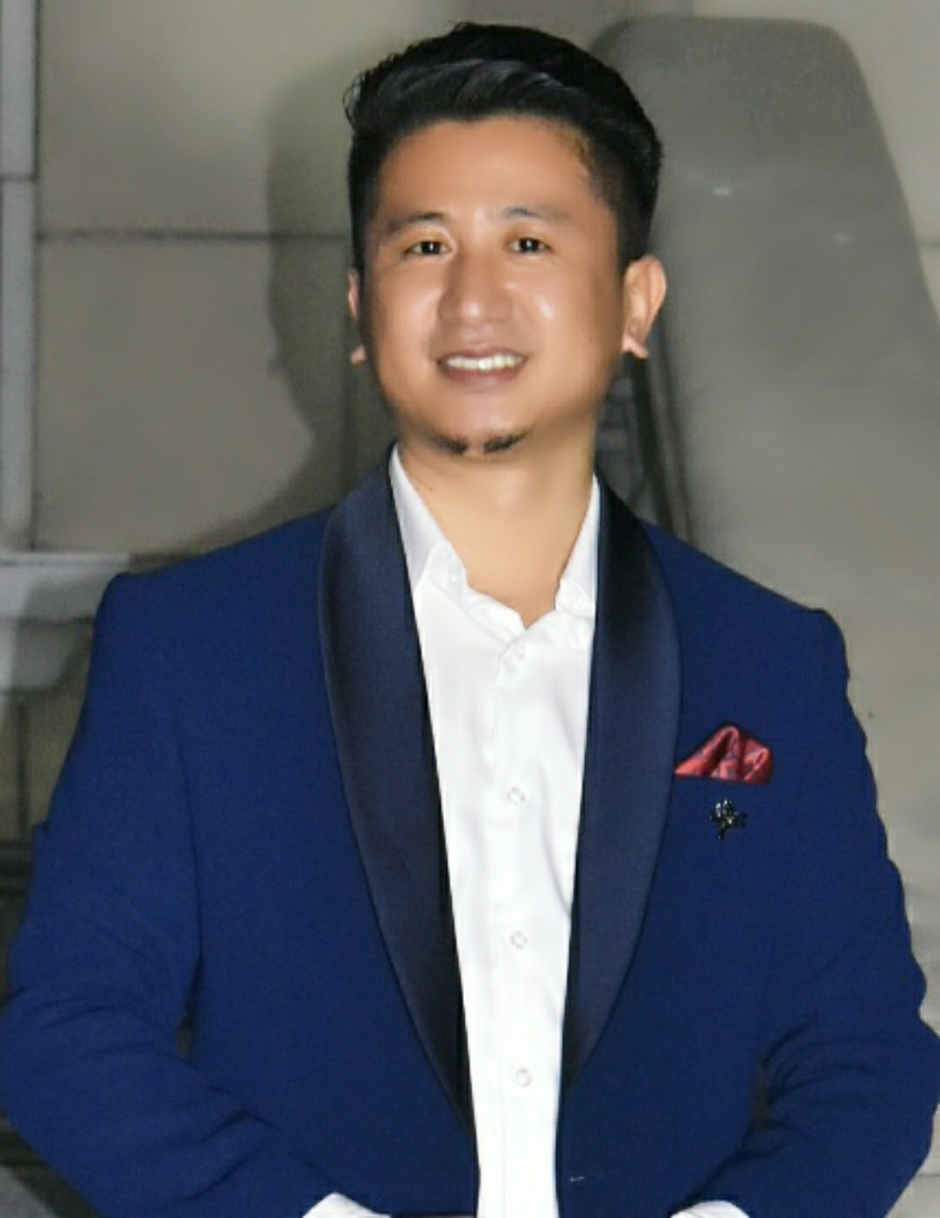 |  |  |  | T Luithuiwung Awungshi  Master of Social Work  Areas of Expertise: Youth Development, Family & Child Welfare
To work in an institution where I can apply my skills and secure a promising position that offers both a challenge and a good opportunity for growth.

Professional Experience
1. 08/10/2014–22/12/2015
*Block Coordinator• Assam State Rural Livelihoods Mission Society
Key Responsibilities
Participatory Rural Appraisal, Capacity Building, Formation of SHGs & VOs, Documentation,
2. 17/02/20–until date
Assistant Professor• The Assam Royal Global University

Education
Bachelor of Social Work (2011) & Master of Social work (2013)
Assam University, Silchar

National Eligibility Test (NET)
Qualified for Assistant Professor

Publications
*2 (National)

Papers Presented
*5 (Five)

Seminar Conference, & Workshop Attended
*10 (Ten)

Faculty Development Programme attended
*2 (Two)

C/O Solomon Kashung
House No. 65, Ahom Gaon, 781035
 |  | 9101257884/9707243164
tlawungshi@rgu.ac
asluithui@gmail.com

